Identifying Drivers of Non-communicable Diseases in Ethiopia: An Approach Using Causal Path Diagrams
Contributed by Tom Norris

On 5th June 2020, the NIPN team hosted an online webinar with a number of invited experts in the fields of nutrition, non-communicable diseases (NCDs), epidemiology and public health.
The purpose of the meeting was part of an on-going analysis the team is conducting which seeks to respond to a relevant policy need as identified by NIPN stakeholders, namely, what are the drivers of non-communicable diseases (i.e. overweight/obesity, hypertension and diabetes) in Ethiopia? The seminar represented an opportunity for the NIPN team to draw upon the expert knowledge of these collaborators which could then be incorporated into a set of causal path diagrams which have been constructed as part of the methodological framework underpinning the analysis.
What are causal path diagrams? Otherwise known as ‘directed acyclic graphs’ (DAGs), these are causal diagrams which provide a method for visualising relationships between variables (Moodie & Stephens 2010), thereby informing the process of building causal models (Bodnar & Nelson 2004). By identifying variables that confound the relationship between two variables, DAGs provide researchers with a set of variables for which adjustment is necessary (or unnecessary) in order to obtain unbiased (or less biased) estimates of the causal relationship between two variables.
The construction of these DAGs are based on a combination of a comprehensive literature review of the research topic (i.e. drivers of NCDs) alongside, crucially, specialist knowledge from experts in the fields related to the research topic (here nutrition, chronic disease epidemiology and public health).
Typically the causal path diagrams are drawn during these consultative meetings with the invited experts, however, in order to facilitate the process, the NIPN team had already prepared a set of preliminary causal diagrams based on a rapid literature review which they conducted. The search was conducted in Pubmed on 27th April 2020 and identified 3442 studies which had sought to identify any predictors of overweight/obesity, hypertension and diabetes in Sub-Saharan Africa.
Identified drivers were extracted and collated by four members of the team. Availability of these drivers were then checked in the datasets which have been identified for use (Ethiopia Demographic Health Survey and NCD STEPS survey).
With this set of identified drivers, the next step was to map out how these were all related to the respective outcomes, and importantly, related to each other. This was done using a piece of software called ‘DAGitty’ (www.dagitty.net) (Textor et al. 2016).
DAGitty applies graphical model theory to identify which variables you need to adjust for in your multivariable analysis in order to remove confounding. However, the user is the one who feeds the variables into the software and tells DAGitty which variables are (and are not related), i.e. the model is only as good as the things you put in.

Based on what the user tells it, DAGitty will then report back a set of adjustments that need to be made in the multivariable models in order to remove confounding from the model we have drawn and thus obtain unbiased (or less-biased) estimates of the association between any given exposure/predictor/ driver and outcome variable. The reliance of the software on the information included by the user is why it is vital to have as many experts involved in the DAG -building process as possible.
For illustrative purposes, a hypothetical DAG can be seen overleaf (exploring the relationship between diet and diabetes). DAGs such as these are being used to inform the next stage of our analysis in which separate multivariable models relating individual drivers to the non-communicable outcomes will be run, with adjustment for the confounding variables identified by DAGitty.
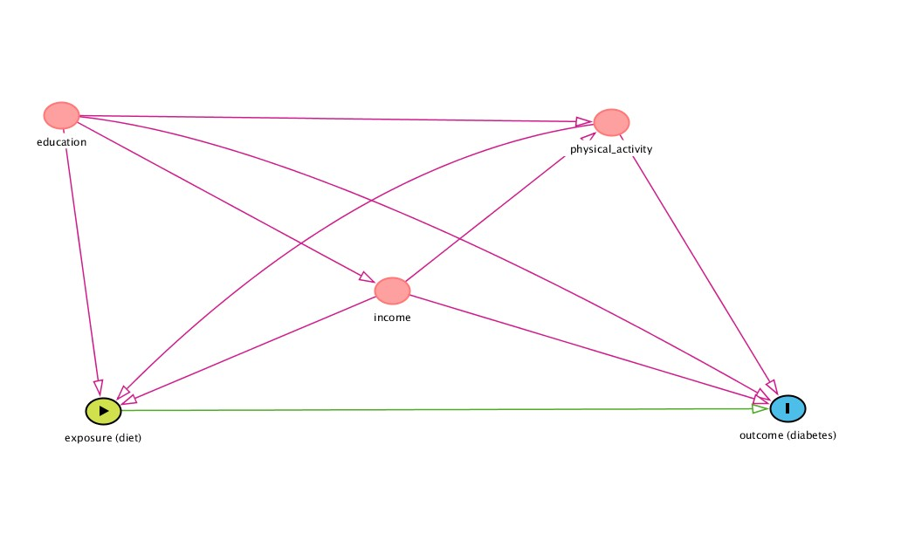
References:
Bodnar, L. M., & Nelson, M. C. (2004). Maternal nutrition and fetal growth: Bias introduced because of an inappropriate statistical modeling strategy may explain null findings. American Journal of Clinical Nutrition, 80(2), 525– 526. https://doi.org/10.1093/ajcn/80.2.525 author reply 526-527.
Johannes Textor, Benito van der Zander, Mark K. Gilthorpe, Maciej Liskiewicz, George T.H. Ellison. Robust causal inference using directed acyclic graphs: the R package 'dagitty'. International Journal of Epidemiology 45(6):1887 -1894, 2016.
Moodie, E. E., & Stephens, D. A. (2010). Using Directed Acyclic Graphs to detect limitations of traditional regression in longitudinal studies. International Journal of Public Health, 55(6), 701–703. https://doi.org/10.1007/s00038010-0184-x.

